6. Climate Change
Local Trends
Local climate is changing: a trend that is expected to continue for the foreseeable future. Averaged across the Skeena Region, almost 2°C of warming occurred during the 20th century. The recent mountain pine beetle epidemic, the spread of Dothistroma needle blight, loss of aspen to defoliators and leaf-miners, and loss of willow to willow borers have all been linked to climate change.
Table XX shows projected annual temperature and precipitation changes to 2050 for selected sub-regions that include DSS’ Timber Supply Areas. In summary, a nearly 2 degree median temperature increase is expected across all TSA’s by 2050. Summer precipitation is expected to decrease in Bulkley and increase in Kispiox and Cassiar. Winter snowfall trends are variable, but significant spring snowfall reductions are projected across all TSA’s.
Expectations are for shorter and warmer winters and hotter summers, combining to increase drought potential and fire hazard. Drought stress can increase susceptibility of trees to insects and disease. More frequent and severe natural disturbances and hydrologic events are expected, threatening communities, timber supply and natural resource values.

Table XX: Projected Annual Temperature and Precipitation Changes to 2050*
Factor | Bulkley-Nechako (Bulkley TSA) | Kitimat-Stikine  (Kispiox TSA;  Cassiar TSA south-west) | Stikine (Cassiar TSA south-east and north)
Median Annual Temp | +1.7°C | +1.7°C | +1.8°C
Summer Precipitation | -2% | +1% | +4%
Winter Snowfall | -5 to +8% | -10 to +8% | +6 to +10%
Spring Snowfall | -58% | -59% | -49%
*Source: Plan2Adapt extract for Regional Districts

Table XX shows present (2015) and projected (2050) BEC variant composition by TSA and calculated % differences. Differences exceeding 10% are shown in red text to highlight significant predicted shifts. In summary it is projected that:
- Bulkley will see a significant increase in prevalence of ICH (mc1 and mc2) and CWHmc2, and significant decrease in ESSFmc and SBSmc2;
- Kispiox will see significantly increased ICH (mc1 and mc2) with corresponding losses to ESSF and alpine variants;
- Cassiar will see significantly increased BWBSdk and ESSFwv and significantly decreased SWB.

As climate envelopes shift, the range of forest pests associated with a particular envelope (e.g. Dothistroma in ICH) is also expected to shift.

Table XXX: 2015 and 2050 BEC Variant Composition Comparison by TSA
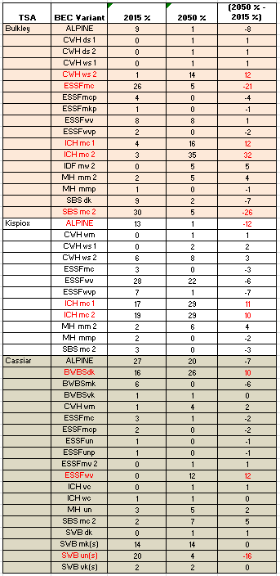

Management Objectives and Strategies
BC’s 2010 Climate Change Adaptation Strategy calls on government to ensure that climate change impacts are considered in planning and decision-making across government, and to implement priority adaptation actions in key climate sensitive sectors.
In their 2014 Climate Change Position Paper, the ABCFP recognizes that adapting forestry practices in light of climate change is consistent with Principles of Forest Stewardship as defined by the Foresters Act, and calls on practising forest professionals to re-examine past approaches, standards and accepted methods of managing our forests to ensure sustainability and good forest stewardship.
FLNRO has focused on developing strategic guidance (e.g. objectives and strategies) and tools to support climate adaptation for forest management, with future plans to expand to other resource values (e.g. water, land, fish, and wildlife habitat). A summary of key strategic guidance and links to source document is provided in Appendix XX.
Management objectives and strategies captured to this section are pertinent to a Forest Health Strategy, and have been adapted from the February 2012 Forest Stewardship Action Plan for Climate Change Adaptation 2012-2017 and the March 2015 draft Skeena Region Action Plan. (INTENT – communicate and provide links to tools, memos; set the stage for Section 7 - District Stocking Standard Recommendations)
Objective 1: Maintain and enhance diversity, i.e. maintain complex and diverse forest ecosystems and landscapes (multiple scales and types) that are resilient to impacts of stressors including climate change.
Objective 2: Manage and protect resources and values – i.e. maintain a full suite of forest resources and values to safeguard future management options and benefits in a changing climate.
Objective 3: Develop adaptation information, knowledge and tools
Objective 4: Increase carbon storage in forests
Objective No. | Strategy
3 | Communicate tools and advice for climate-based seed transfer
1, 3 | Communicate tools and advice for tree species selection
1 | Use TSA-level Forest Health Strategies to capture and communicate tree species diversity and density objectives consistent with Chief Forester Policy, at the landscape level, that address climate change consideration (PIR FLRS reference?)
2, 4 | Build fire-resilient landscapes (fire management stocking standards; fuels corridor mgt)
 | Employ analysis to assist in setting adaptation priorities
3 | Develop climate change inputs for Timber Supply analysis: growth and yield, regeneration success, disturbance, and adaptation measures
3 | Develop a fully integrated stand monitoring process from establishment to harvest: regeneration to free growing (0 – 20 years); Stand Development Monitoring (20 – 40 years); and young stand monitoring (15 -50 years)
1, 3 | Communicate knowledge and tools that support decisions in addressing climate change in Forest Stewardship Plans
2, 3 | Use TSA-level Forest Health Strategies signed off by District Managers annually to provide District stocking standard recommendations - SEE SECTION 7
4 | Communicate knowledge and tools that support improved carbon management
4 | Identify landbase to include in future carbon projects

Strategy: Tools and Advice for Climate-Based Seed Transfer
Reference CF Seed Use Policy. There’s still a CF Seed Use Policy 5% cap on transferring seed from outside an SPZ
Western larch policy review
- To summarize – previous guidance too restrictive and not as straight forward for operational use as desired.
- New 2014 policy – Collapsed Lw 1 and Lw 3 zones together (entire area is SPZ Lw1, there no longer is Lw3), expanded boundaries of Lw1 and Lw2, and smoothed boundary line.

Strategy: Tools and Advice for Tree Species Selection
Updates to the Reference Guide for FDP Stocking Standards (2014): Climate-Change Related Stocking Standards (Initial direction focussing on 01 zonal associations, offers a good starting point for making climate change based species selection decisions).
Regional Guidance for Species Use Based on Climate Change project (Bruce Rogers, others) - based on projected site level changes. Still need to consider other limiting factors or have additional cautionary footnotes
BEC Ecologists asked to participate in Phase 1 of the project using available tools to develop Reference Guide promotion/demotion rankings for species at the site series level (focused on the zonal 01 site series to start with).
3) ClimateWNA Model
BEC Database Tool - Ecosystem/climate niches incorporated into queries in the BEC data base and linked to the tables in the Reference Guide to produce a “% area change for existing BGC climate envelopes to future ones” for 2020, 2050 and 2080 along with the corresponding new suggested species selection (Rough-cut level).
2080 example output for the SBSdk
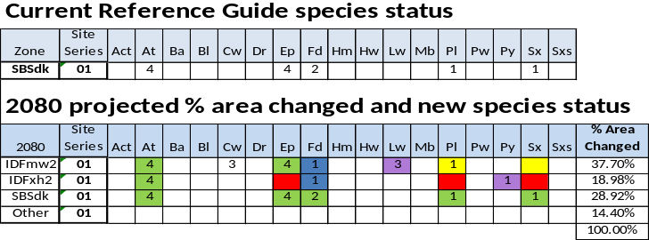
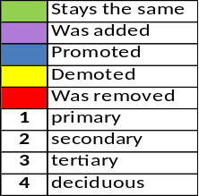

The Drought Species Risk Tool (DeLong et al. 2010-FFESC) projects future changes to actual soil moisture regime (ASMR), recently developed as part of Future Forest Ecosystems Scientific Council Project
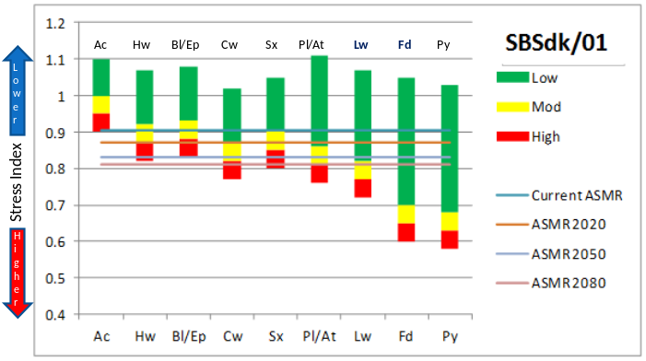
Strategy: Tree Species Diversity and Density Objectives
Objectives and targets for increased tree species diversity, including deciduous species, through all seral stages – reference Kevin Astridge/ Shirley Mah work
Objectives and targets for stand density through all seral stages
Achieve landscape-level species targets using both landscape-level and stand-level approaches
“There are three ways to achieve a mixture of species:
- at a landscape or forest-wide level in discrete stands;
- at a cutblock level in discrete patches;
c) at a stand level with evenly dispersed or clumped distribution.
Each approach has advantages and disadvantages from both an operational perspective and climate change risk-reduction perspective. Longer rotations have a need for greater resilience, suggesting fine-scale mixtures; shorter rotations support broad-scale mixtures.”

Stand-level – thinking about how trees grow together is important
Predicting growth of novel mixtures of species is tricky.
Species with different shade tolerance or growth rates, even dispersion is not recommended unless the intent is to create a two-storied stand that is harvested in two stages (e.g., Fd and Cw).
Clumped distribution - some of the benefit of self-adjustment is lost, depending upon the size of the gaps.
A final caution: beware of too many admixed species at the stand level that could complicate management unnecessarily.

A combination of landscape- and stand-level approaches is recommended for maintaining species mixtures.

Landscape
Type 4 Silviculture Strategies have species direction at the Subzone level as desired trends and or targets, e.g., for SBSdw in the Quesnel TSA

Stand
Where there is uncertainty about the viability of a particular species (e.g., Pw and blister rust, Yc on wet soils with low snowpack and spring frost concerns), or where species occupy complementary niches, leading to higher total volume, then a stand-level mixed-species approach is preferred.

A recent discussion paper by Lilles and Coates (2014) found that it was not possible to make generalizations about the yield of mixed stands vs pure stands due to the confounding factors of species composition, site type, density and pattern, and assessment age. Foresters are advised to extrapolate from specific studies with careful attention to these factors.”

Strategy: Fire Resilient Landscapes
- Ability to provide win/win scenarios
  - Ecosystem restoration
  - Hardwood production
  - Fire hazard reduction
- Consistent with Chief Forester Guidance on:
  - Incorporating mixedwood and broadleaves
  - Tree species composition at stand and landscape scales
  - Maintaining/recruiting habitat
  - Use of western larch
  - Immediate and long-term forest health issues
- Why – Protection of life and property and enhancement of the delivery of ecosystem goods and services from forests within BC
- Where – where should fire management stocking standards apply?
- When – at what point(s) in the life of a stand should stocking standards apply?

Where:
- Within approx 2 km of interface
  - Provincial strategic threat analysis (PSTA) map
- Within approx 2 km of other high value infrastructure on the landbase
  - Fire Management Plan Values Maps
  - Additional defined by Designated Decision Maker
- Where identified by fuels management plan within the fire management plan
  - Based on landscape scale fire management objectives

Does not necessarily have to be applied to entire harvest blocks
- Usually adjacent to value to be protected
- On other appropriate standard units
- More than one fire management standard could be developed
  - May be desirable to create a diversity of fuel types
  - Spatial arrangement of fuel types is important – locally and landscape
When:
- At different forest sucessional stages
  - Regeneration/ Free growing
  - Partial harvest with regeneration objectives
  - Intermediate Cut
- When identified by fuels management plan within a fire management plan
  - Based on landscape scale fire management objectives
  - May apply to any/all phases of forest production

- Objectives - May be Landscape or Local
  - Landscape
    - Reduce fire size
    - Reduce fire behaviour
  - Local
    - Reduce fire behaviour
    - Reduce likelihood of crown fire
    - Reduce fire intensities
    - Reduce rate of spread
- In both cases – typically include enhanced suppression effectiveness and success as an objective

- Western red-cedar may be considered the most flammable of the coniferous species considered due to tendency to retain foliage and oil.

Fire Mgt Stocking Standard becomes the combination of:
- Fire management objectives
- Stand structure considerations
- And other compatible objectives (e.g. Timber production, ecosystem restoration, hardwood production, etc)

Strategy: TSR considerations
Speak to OAF, GW
TSR Concerns
OAF2 is a TIPSY yield curve adjustment factor intended to account for losses that increase with stand age – pests, diseases, and decay/waste/breakage.
District are concerned that a 5% OAF2 may ultimately prove too low for existing managed stands, as climate change plays out. Whole-scale BEC variant shifts to drier or wetter types are predicted to occur within 20 years, which will put plantations under increasing stress.
Using the provincial default OAF2 of 5% could be lowballing losses due to forest health problems in young stands, given the prevalence of root rot, rusts, needle blights, and damaging insects and their apparent increasing trend with warming temperatures and changing patterns of precipitation. Is the trend increasing?
• FAIB are implementing a young stand monitoring program to assess second growth stand yield performance relative to TIPSY projections and reinvestigate yield curve adjustments.

Genetic Worth - District and the Regional Pathologist are mutually concerned that base case GW assumptions may not hold true as predicted climate shifts occur over the next 20-50 years

• Tree Improvement Branch advises that Genetic Worth estimates consider emerging science and best available information in the verification process. They state that predicted gains from selection and tree breeding are founded on 80 years of research worldwide, and substantiated by >15 years of progeny testing and numerous field-based realized gain trials throughout BC.
• However, they also acknowledge that as climate changes, populations will become increasingly maladapted resulting in slower growth and poorer health. This advice tends to substantiate concerns.

Climate change may affect the growth of future stands. However, the magnitude, direction and rate of that change will vary at regional versus local scales. Research analyses, supported by climate models, suggest that maladaptation associated with climate change will be greatest in north and interior regions.
Forest Act Sect. 8(8)(a)(ii) Genetic Worth
58
In general, as climate changes, populations will become increasingly maladapted, resulting in slower growth and poorer health. Assisted migration of tree species beyond their current range may partially mitigate, and possibly reverse, the impact in some areas of the province (District comment – in essence, this response supports the comment).

Strategy: Integrated stand monitoring

Strategy: Forest Stewardship Plans and Climate Change
Memos and Guidance…
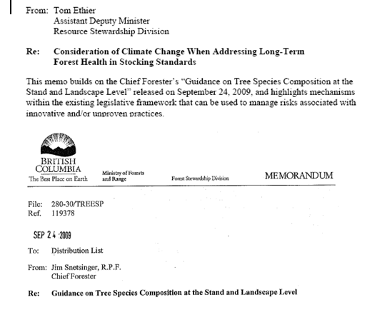
Also include extract from Approval letters to FSP extensions

Strategy: Carbon Management

http://www.livesmartbc.ca/attachments/Adaptation_Strategy.pdf
http://www.abcfp.ca/publications_forms/publications/documents/ABCFP_Climate_Change-Position_Paper_2014.pdf
https://www.for.gov.bc.ca/ftp/HFP/external/!publish/ClimateChange/Adaptation/MFLNR_CCAdaptation_Action_Plan_2012_final.pdf

